**Project –3**

Aim – access ec2 server when key lost and putty connect not working

Core diagram

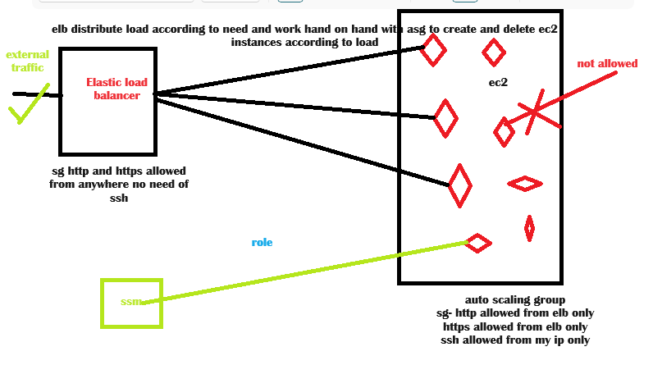

Steps to do this –

1. Create sg of elb where only http and https open
2. Create sg of asg where https allowed from custom and https allowed from custom i.e allow from elb only.
3. Create template for asg where give sg of asg
4. Create load balancer
5. Create asg
6. Now the main challenge here is we can not access ec2 instances from putty, web browser, ports, key pair all but if we allow system manager to access ec2 we can easily access ec2 instances just need to add role to ec2 .we can connect role to running instance.

Testing results –

check ip address working on web ---- no

Load balancer DNS -------------- yes

Able to login ec2 -

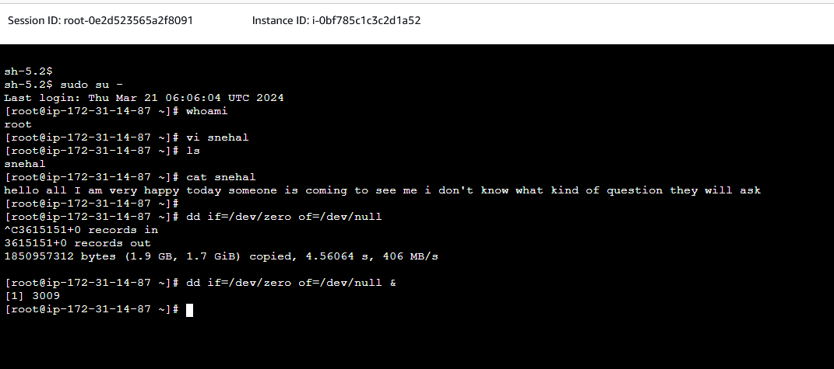

Load balancer testing for different ec2 instances -

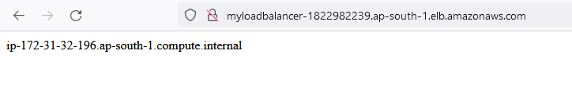

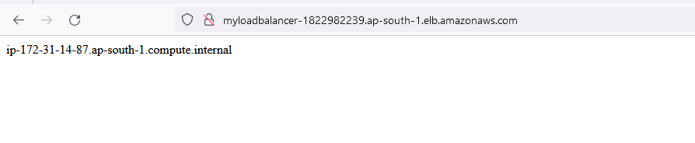

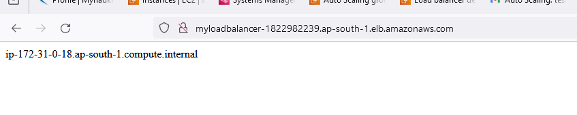

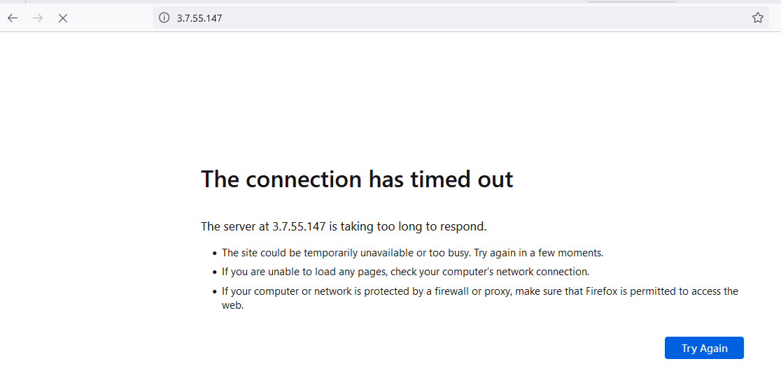

Instances auto scale out

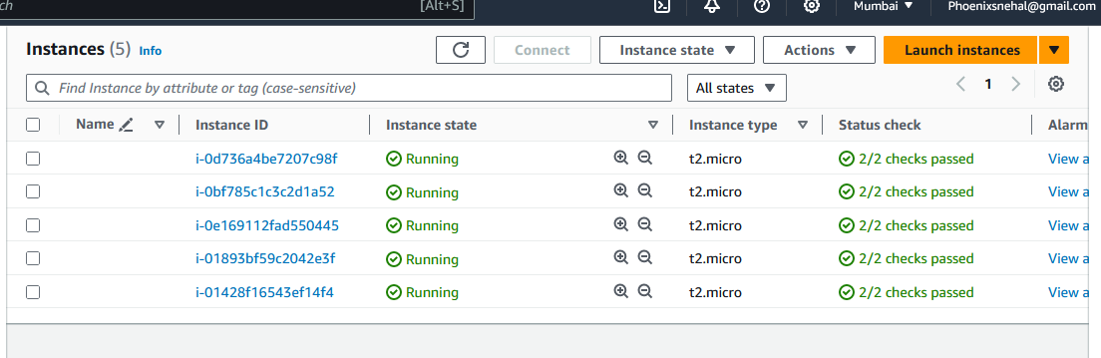

Observation –

1. Here we can solve multiple issues
2. Security from external traffic
3. Auto healing using asg scale out and scale in.
4. Load distributes equally.
5. Eliminate the error as no human dependencies.